Name : Kirtesh Satish Admute
Roll No. : 258039
PRN : 250841220082
Module : DBT

-- 1. To list all records with sal > 2000 and comm>200
SELECT * FROM EMP
WHERE sal > 2000 and comm > 200;



-- 2. To list all record with job=’Clerk’ or sal>2000
SELECT * FROM EMP
WHERE job = 'Clerk' OR sal >2000;
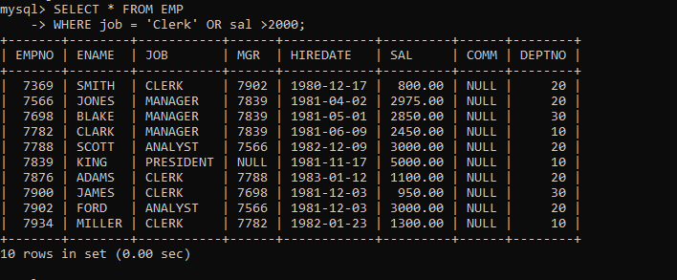

-- 3. To list all the record with sal=1250 or 1100 or 2850
SELECT * FROM EMP
WHERE sal IN(1250, 1100, 2850);
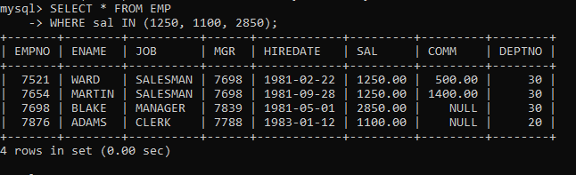

-- 4. To list all employees with sal>1250 and <2850
SELECT * FROM EMP
WHERE sal BETWEEN 1250 and 2850;
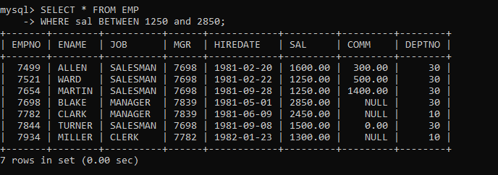

-- 5. To list all employees with name ends with AS
SELECT * FROM EMP
WHERE ename LIKE '%AS';


-- 6. To list all employees with job starts with C and ends with K
SELECT * FROM EMP
WHERE job LIKE 'C%K';
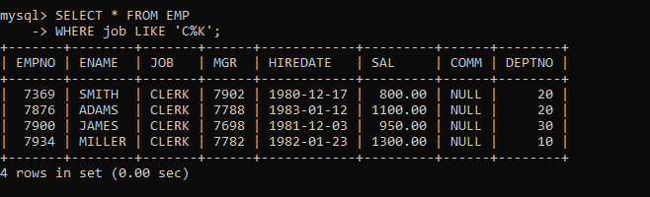

-- 7. To list all employees with job contains L at third position and M at third last position
SELECT * FROM EMP
WHERE job LIKE '__L%' and
job LIKE '%M__';
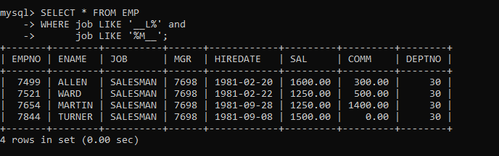

-- 8. To list all the record with sal not equal to 1250 or 1100 or 2850
SELECT * FROM EMP
WHERE sal NOT IN (1250, 1100, 2850);
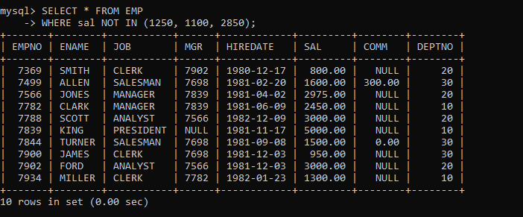

-- 9. To list all employees with salnot >1250 and <2850
SELECT * FROM EMP
WHERE sal NOT BETWEEN 1250 AND 2850;
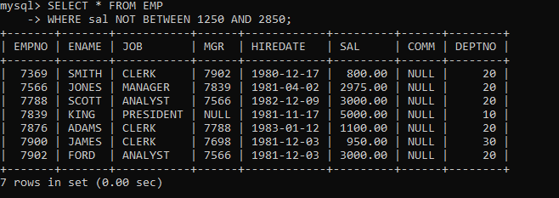

-- 10. To list all employees with job starts with C , E at 3rd position and ends with K
SELECT * FROM EMP
WHERE job REGEXP '^C.E.*K$';
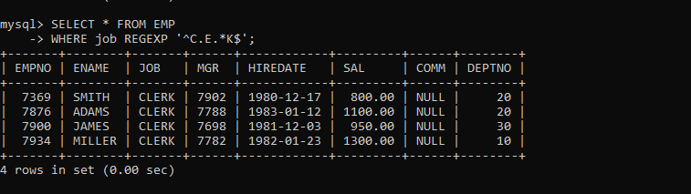

-- 11. To list all rows with comm is null
SELECT * FROM EMP
where comm IS NULL;
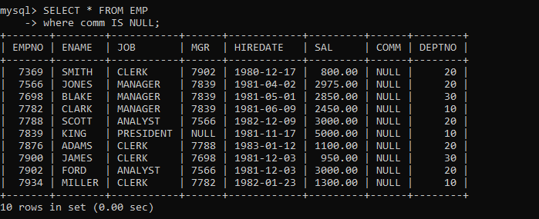

-- 12. To list all employees with sal is null and name starts with ‘S’
SELECT * FROM EMP
WHERE sal is NULL and ename LIKE 'S%';


-- 13. To list all employees with job contains 5 characters
SELECT * FROM EMP
WHERE job REGEXP '^[a-z0-9]{5}$';
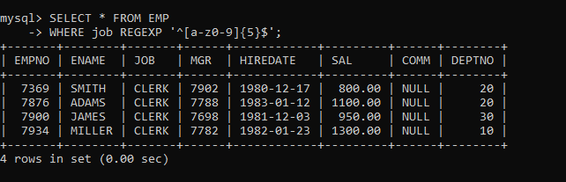

-- 14. To list all employees with name contain ‘A’ at 1 position and job Contains 5 characters
SELECT * FROM EMP
WHERE ename REGEXP '^A' and job REGEXP '^[a-z]{5}$';
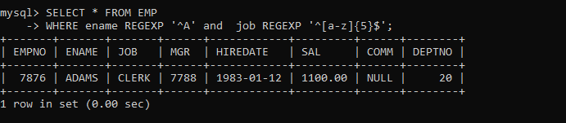

Q2. Solve the following

/*
1. Retrieve the details (Name, Salary and dept no) of the emp who are working in
department code 20, 30 and 40.
*/

SELECT ename, sal, deptno FROM EMP
WHERE deptno IN (20, 30, 40);
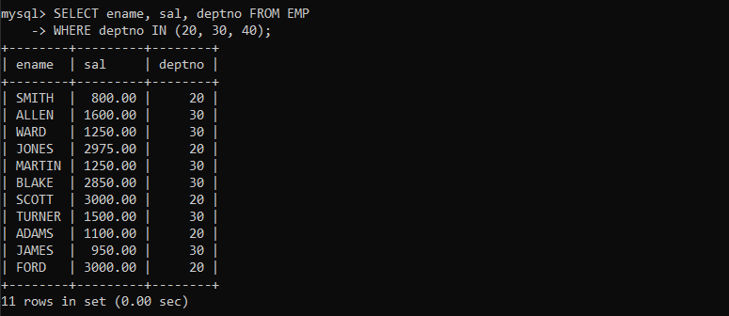

/*
2. Display the total salary of all employees . Total salary will be calculated as
sal+comm+sal*0.10
*/

SELECT SUM(sal + comm + sal * 0.10) as "Total Salary" FROM EMP;
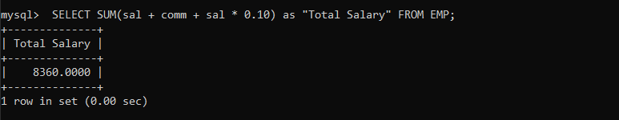

/*
3. List the Name and job of the emp who have joined before 1 jan 1986 and whose
salary range is between 1200and 2500. Display the columns with user defined Column
headers.
*/

SELECT ename as "EMP Name", job as "Job Role" FROM EMP
WHERE hiredate < '1986-01-01' and sal BETWEEN 1200 AND 2500;
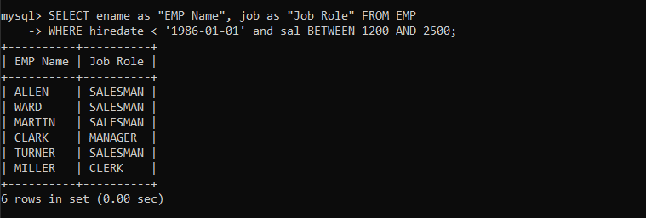

/*
4. List the empno, name, and department number of the emp works under manager
with id 7698
*/

SELECT empno, ename, deptno FROM EMP
WHERE mgr = 7698;
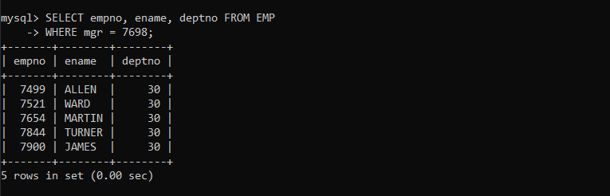

/*
5. List the name, job, and salary of the emp who are working in departments 10 and
30.
*/
SELECT ename, job, sal FROM EMP
WHERE deptno IN (10, 30);
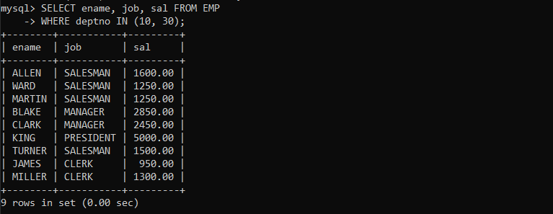

/*
6. Display name concatenated with dept code separated by comma and space. Name
the column as ‘Emp info’.
*/
SELECT CONCAT(ename," ",deptno) as "Emp Info" FROM EMP;
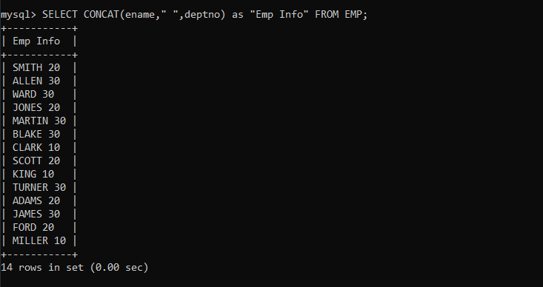

-- 7. Display the emp details who do not have manager.
SELECT * FROM EMP
WHERE MGR IS NULL;
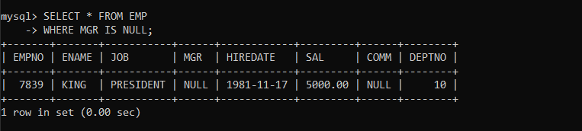

/*
8. Write a query which will display name, department no and date of joining of all
employee who were joined January 1, 1981 and March 31, 1983. Sort it based on date of
joining (ascending).
*/
SELECT ename, deptno, hiredate FROM EMP
WHERE hiredate IN ('1981-01-01', '1983-03-31')
ORDER BY hiredate DESC;
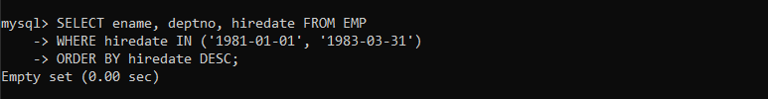

/*
9. Display the employee details where the job contains word ‘AGE’ anywhere in the Job
*/

SELECT * FROM EMP
WHERE job LIKE '%AGE%';

SELECT * FROM EMP
WHERE job REGEXP 'AGE';
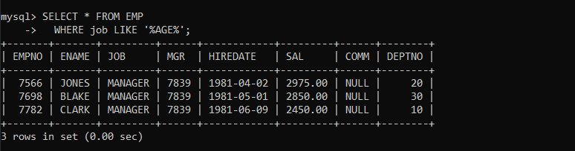

/*
11. List the details of the employee , whose names start with ‘A’ and end with ‘S’ or
whose names contains N as the second or third character, and ending with either ‘N’ or ‘S’.
*/
SELECT * FROM EMP
WHERE ename REGEXP '^A.*S$ | ^..?N.*[NS]$';


-- 12. List the names of the emp having ‘_’ character in their name.
SELECT * FROM EMP
WHERE ename REGEXP '_';


-- Group functions

-- 1. Display the Highest, Lowest, Total & Average salary of all employee. Label the columns
-- Maximum, Minimum, Total and Average respectively for each Department. Also round the
-- result to the nearest whole number.

SELECT deptno as dept,MAX(sal) as max,MIN(sal) as min, SUM(sal) as Total,AVG(sal) as avg FROM EMP Group By dept ;
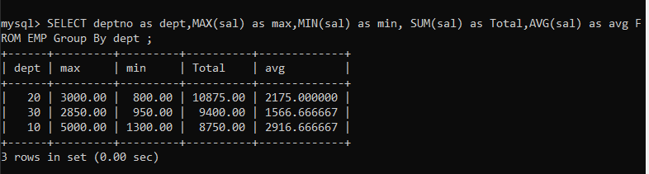

2

-- 2. Display Department no and number of managers working in that department. Label the
-- column as ‘Total Number of Managers’ for each department.

SELECT deptno ,COUNT(mgr) as 'Total Number of Managers'from EMP Group By deptno;

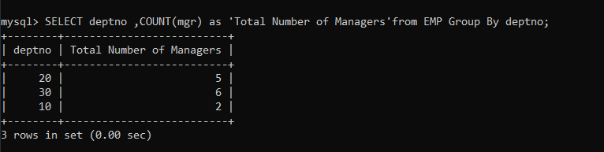

-- 3. Get the Department number, and sum of Salary of all non managers where the sum is
-- greater than 6500

SELECT deptno, SUM(sal) as sal FROM EMP
WHERE job != 'Manager'
GROUP BY deptno
HAVING SUM(sal) >6500;

